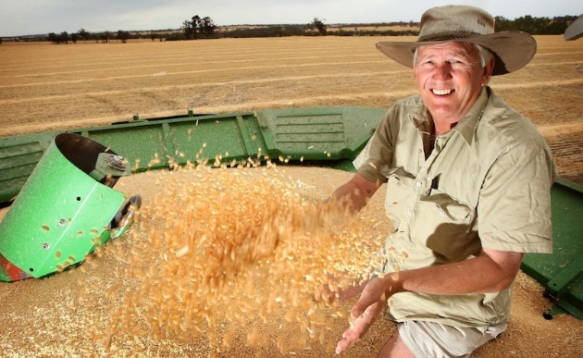
GM back in the spotlight
The West Australian
Friday, 15 December 2017 7:35AM
PGA grains committee chairman Gary McGill.Picture: Astrid Volzke
WA farm lobby groups are concerned an inquiry into compensation for non-GM farmers will explode into a broader campaign against the gene technology.
A new Senate committee parliamentary inquiry will examine potential compensation schemes for farmers who claim economic loss because of genetically modified material.
The landmark inquiry was sparked by a 900-signature petition from European consumer rights organisation FOODwatch, tabled by Greens MLC Diane Evers earlier this year. It called for “farmer protection legislation to compensate any non-GM farmers who suffers economic loss form GM contamination”.
But supporters of the technology this week flagged concerns about the inquiry.
Both the Pastoralists and Graziers Association of WA and WAFarmers agreed there was “no need” for the examination and common law should cover what PGA labelled “very rare” instances of farm-to-farm contamination.
PGA grains committee chairman Gary McGill said the inquiry was a “tactic by the anti-GM movement” designed to “intimidate the cautious GM farmer”. “If someone, through some incursion, suffers economic loss, for example through a crop over-spray... our public liability program looks after these things,” he said.
“We will argue there is no need for any special legislation... common law, discussions over the fence - most people are reasonable - they have a yarn and work it out.”
WA Agriculture Minister Alannah MacTiernan said she supported the inquiry, which comes almost two years after the Marsh versus Baxter case, in which Kojonup farmer Steve Marsh unsuccessfully sued his neighbour Michael Baxter over GM canola contamination.
“We need to ensure that GM and non-GM farming can co-exist,” she said. “Growing GM crops makes financial sense for some, but if neighbouring farmers growing organic crops lose money as a result of contamination, we need to look at whether that financial burden should be shared.”
“We will await the outcome of the committee’s inquiry and encourage stakeholders to make a submission.”
Ms Evers said the rights of non-GM farmers were not sufficiently protected by law.
“It is apparent from the case of Kojonup farmer Steve Marsh that the rights of non-GM farmers in WA, who outnumber farmers growing GM, are not sufficiently protected by law,” she said.
“For as long as farmers want to meet demand from consumers for non-GM products, the risk of their fields being contaminated and them experiencing economic loss will remain.
“WA farmers should not lose their right to sell non-GM crops at a higher price, due to the actions of another grower. This is an issue that cannot be ignored.”
Hundreds of thousands of hectares of GM canola is grown in WA each year after the Barnett Government changed regulations in 2010.
Previously, WA was classed a GM crops-free zone with just two exceptions, GM canola grown Statewide and GM cotton in the Kimberley’s Ord irrigation area.

Study raises health concerns over GM crops
Rebecca Dollery
Updated 23 Sep 2012, 8:36am
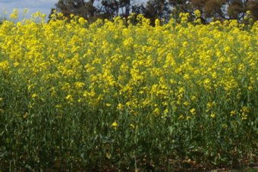
PHOTO: In 2010 the WA Government lifted a ban on GM crops.(User supplied)
RELATED STORY: Cancer in rats reignites GM food debate
The second study this month to link genetically modified crops with serious health problems has prompted calls for the WA government to ensure the State's GM crops are safe.
The latest study, published in the journal of Food and Chemical Toxicology, shows rats fed a GM corn diet over their two year lifespan, suffered mammary tumours and severe liver and kidney damage.
The corn, produced by the American multinational Monsanto, had been sprayed with the company's weedkiller, Roundup.
The State Government controversially lifted a ban on GM crops in 2010.
At least 10 per cent of WA's canola crop is now genetically modified and GM wheat trials have been conducted at locations around the State.
The decision to lift the ban has since been the subject of international attention.
Earlier this year a Kojonup farmer took his neighbour to the Supreme Court for allegedly allowing a GM canola crop to contaminate his organic farm.
Anti-GM campaigners say the State Government could put farmers and consumers at risk if it doesn't instigate an urgent assessment of the use of GM and Roundup in WA.
The director of Australia's Safe Food Foundation, Scott Kinnear, says the WA Government has a responsibility to pay attention to the latest study on rats.
"The Government would be wise to have a look at this research and a lot of the other indicator research," he said.
"There is now a plethora of research that is building to show harm from GM."
Mr Kinnear said he did not think banning GM products altogether was the answer.
"It's too early to call for a ban on GM, but what we should call for is a change in the way we regulate GM."
Full confidence
In a statement the WA Minister for Agriculture Terry Redman said the Government has full confidence in the Australian regulatory system for GM products.
"Which includes both Food Standards Australia New Zealand and the Office of Gene Technology Regulator," he said.

